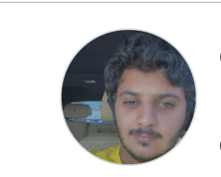

Project Proposal

**Group members**:

Gerald Edeh: Java & C (newbie)

Chimzim Ogbondah: Java & C, python

3 Internships with John Deere (customer Product Support, Product Engineering, Autosar Engineering) experience AGLIE & SCRUM sprints

Omar Almehairbi

Omar Alsaedi: Java and C senior

**Problem being addressed**: Iowa State Campus Delivery

**Description**: As of right now there is no campus delivery service, so if you want something from a place on campus you must leave and get it yourself. Our Idea will solve this problem by creating an app to allow students to order food from different dining locations and create a route for their delivery on campus.

We plan for our project to work for Students, staff, and visitors. We will allow all users to create an account with the app for easier check out the next time around. We want students and staff to have a way for the university to bill them. We will use knowledge of maps and algorithms to create a plane for isu camps and then create a route from dinning location to client location using GPS services. Message authentication will be required (cryptography) via text/email for receipt confirmation and updates on delivery. User Interfaces for the potential automated delivery and app will be created.

**Language and IDE**: Java : Eclipse

**What makes this project large and complex:**

* Networking with server
  + Different menu websites
* Connecting to APIs
  + Cryptographic algorithms (hashing)
* Databases
  + Potentially using isu ID numbers(net ID)
* Number of Screens
  + Multiple users at the same time
* Mobile device
  + Using location services to create a route for the delivery
  + Use of mobile wallet ?